Guide 2. APT Project Development
Capstone Course

1. APT Project Progress Summary
Complete the following fields with the requested information.

APT project progress summary | Galactum is a space strategy game. Team 3 develops World and Combat: entities, fleet movement, mining, xenoforms and encounter resolution. Phase 2 includes MVP v0.12, with a Godot client and an authoritative server, and a reproducible deployment using Docker Compose.  Specific objectives and progress  • Environment: Godot 4.6.2 project using GDScript, JSON catalogs and separate client, server, data and interface components.  • World: solar system, asteroids, xenoforms, ships and fleets. The test session confirmed map navigation and entity selection.  • Mining: selection of a level 1 copper asteroid, deployment of a 38-unit fleet and observation of its march. The copper display increased from 1.2 K to 1.7 K after the round trip.  • PvE combat: deployment of 50 drones and 34 pilots against a level 2 Mist Weaver. The report showed 4,200 damage, the target defeated and 17 wounded units.  • Communication: the web client uses WebSocket through Nginx, while the server retains authority over actions. The prototype's commander identity is not production authentication.  • Deployment: galactum-server:0.12 and galactum-web:0.12 images built; server healthy and galactum_galactum-data volume created, according to the Docker output supplied during execution.  The MVP also includes supporting systems for the demonstration. This integrated scope is distinguished from Team 3's formal responsibilities. Pending checks include two simultaneous clients, saved-game recovery after container recreation, performance and documented execution of the automated suites.
Objectives | The objective is to deliver a functional, integrable World and Combat module, with state synchronization and verifiable evidence. Web deployment supports academic review without installing Godot on the evaluator's computer.  • World: progress from initial M0/M1 synchronization to the playable MVP workflow.  • Interaction: verify entity selection, fleet movement and resource extraction.  • Combat: verify troop selection, energy cost and hunting results.  • Quality: complete reproducible tests, record results and maintain traceability between requirements and evidence.
Methodology | The academic repository's plan specifies Scrum with two-week iterations, regular coordination, feature branches and a tracking board. Technical work is organized into demonstrable increments: connection, world replication, interaction, mining and combat.  This submission adds reproducible deployment: Docker builds the server and exports the web client. Manual tests are documented with real screenshots; available test commands are not reported as passed without execution output.
Progress evidence | Evidence submitted  • Implementation reviewed: mvp-v0.12, with world.gd, spatial_hash.gd, fleets.gd and combat_resolver.gd as Team 3 components. Academic documentation describes their purpose without reproducing confidential code.  • Available tests: run_tests.tscn, server_smoke.tscn and balance_harness.tscn. Execution output for this submission remains to be attached.  • Real screenshots: bilingual start screen, ship, map, asteroid, mining fleet composition and march, hunt preparation and combat report.  Test commander's ship  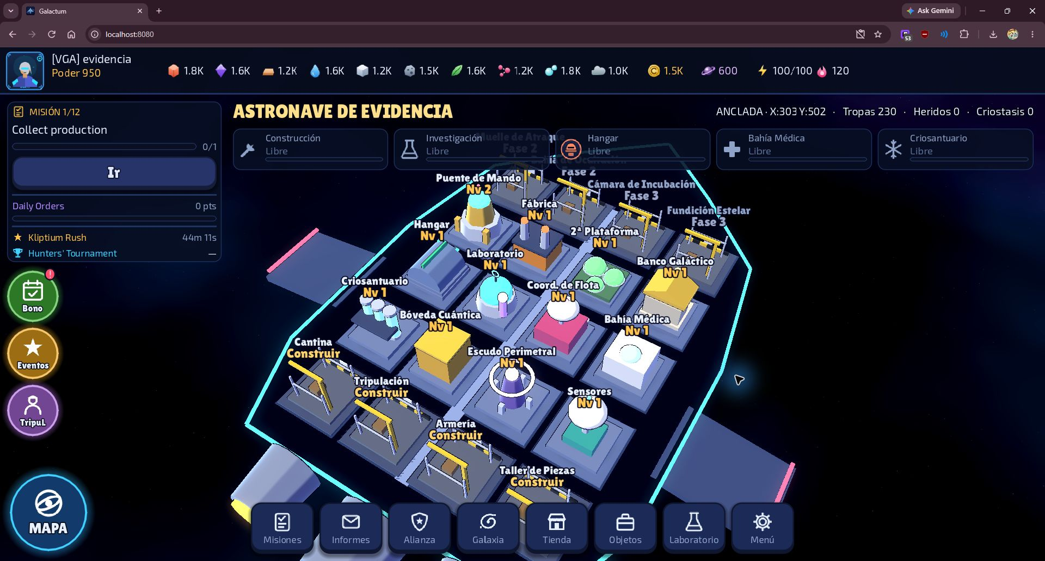  Solar system map  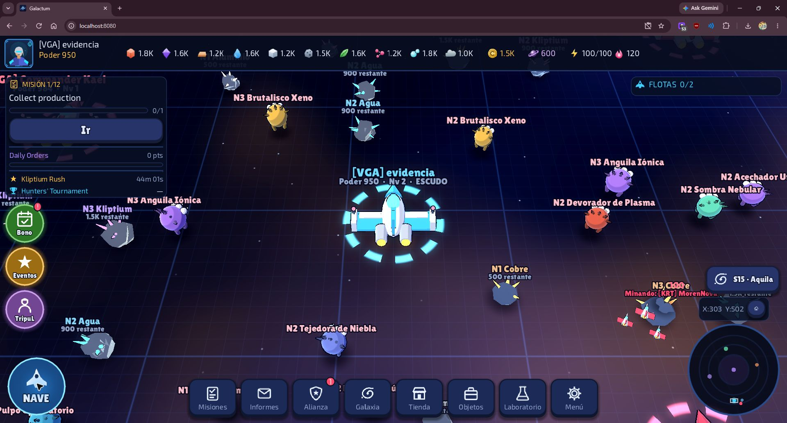  Hunt report showing damage, rewards and wounded units  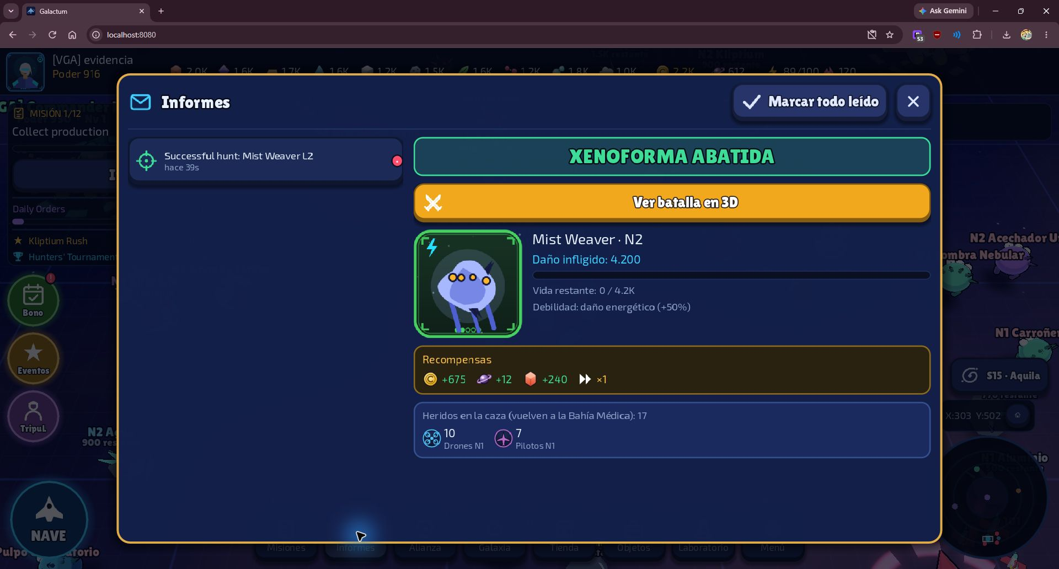  • Academic deliverables: published Phase 1 documents and individual journals, together with this Phase 2 update. The presentation will be prepared later.  Quality assurance  The design separates logic from presentation, keeps balance data in JSON and maintains server authority. Docker configuration includes health checks and volume-based persistence. Screenshots establish what was observed; code review identifies available functionality, and pending validations are stated explicitly.
2. Work Plan Monitoring
Review the work plan carefully, paying particular attention to progress status and adjustments.

Work Plan
Competency or competency units | Activities | Resources | Activity duration | Responsible | Observations | Progress status | Adjustments
Solution analysis | Define World and Combat scope | Galactum documentation | Phase 1 | Team 3 | Separate integrated scope | Documented | Maintain boundaries
Software development | Environment and WebSocket | Godot, GDScript, Git | M0 | Lucas / team | As planned | Implemented | Validate end to end
Software development | Spatial index and AOI | spatial_hash.gd | M1 | Mateo | As planned | In code | Measure performance
Software development | Snapshots and replication | Client and server | M1 | Mateo / team | As planned | In code | Test reconnection
Software development | Selection and map | Godot interface | M1–MVP | Team 3 | Map screenshot | Observed | Record test case
Software development | Marches and travel | fleets.gd | MVP | Lucas / team | As planned | March observed | Validate other travel
Software development | Asteroid mining | Catalogs and fleets | MVP | Lucas / team | L1 copper, 38 troops | Observed | Complete edge cases
Software development | Xenoforms and respawn | world.gd and data | MVP | Mateo / team | As planned | Selection observed | Validate respawn
Software development | PvE combat resolver | combat_resolver.gd | MVP | Lucas and Mateo | Report: 4,200 damage | Observed | Run test suite
Software quality | Combat balance | Existing harness | Closing | Lucas / team | As planned | Not run yet | Attach CSV
Infrastructure | Docker and web client | Docker, Nginx, Godot | Phase 2 | Team 3 | Build output from Lucas | Built | Validate persistence
Software quality | Suite and smoke test | Test scenes | Closing | Team 3 | Existing code | Output pending | Do not report passed
Software quality | Two clients and saving | Browsers, volume | Closing | Team 3 | Documented protocol | Pending | Run workflow
Software quality | Android and profiling | APK, Godot, metrics | Closing | Mateo / team | As planned | Evidence pending | Test device
Project management | Reports and presentation | Duoc UC templates | Phase 2 | Whole team | Presentation later | Reports in preparation | Team review

3. Adjustments Based on Monitoring
Expand on the work plan observations. Analyze the planned activities and identify factors that helped or hindered implementation. Explain how obstacles were or will be addressed, and describe the resulting adjustments to the plan.

Factors that helped or hindered implementation of the work plan:
Enabling factors
• Lucas Orellana and Mateo Orellana have technical responsibilities described in the plan. Juan Castro is a team member; his specific technical assignments must be confirmed before attributing modules to him.
• Godot, GDScript and JSON support execution and explanation of the prototype using open tools.
• Separate academic and game repositories support evidence collection while respecting confidentiality.
• The same server can run embedded for the native demo or as a dedicated process for client connections.
Difficulties and actions
• Environment differences: Docker brings together the engine, dependencies and Linux resource import, reducing manual setup.
• Web export: requires WebAssembly and WebGL 2. Nginx serves the client, which connects through the same-origin /ws endpoint.
• Incomplete validation: suites and saving functionality exist, but execution output and a saved-game recovery test remain to be attached.
• Language: some HUD and report labels remain in English after selecting Spanish. The evidence records this limitation.
• Evidence and coordination: documents and screenshots are consolidated by phase for review by the team and instructor.

Activities adjusted or removed:
Technical and documentation adjustments in this submission
• Deployment: Docker Compose adds a Godot server and a web client served by Nginx. Native PC and Android modes are preserved.
• Web connection: Play connects to the dedicated server through a same-origin WebSocket, avoiding reliance on Docker's internal address from the browser.
• Persistence: /data is mounted to preserve the server's JSON file. This does not add PostgreSQL, SQLite or another SQL engine.
• Data and evidence: Galactum catalogs, persisted state and reports are documented instead of copying models from another project.
• Scope: other teams' systems are not attributed to Team 3's original responsibilities; their presence in the integrated MVP is described.

Activities not started or delayed:
Outstanding closing activities
• Run and retain output from the canonical suite, smoke test and balance harness. Interface screenshots do not replace these tests.
• Verify two simultaneous clients and persistence after recreating containers without deleting the volume. Record steps and results.
• Consolidate performance metrics and Android tests. Prepare the presentation and confirm final assessment criteria with the instructor.

En caso de que el Proyecto APT sea grupal, en esta columna deben indicar el nombre de los responsables de cada tarea o actividad. Esto posteriormente permitirá diferenciar la evaluación por cada integrante.

